**Web Engineering**

123 Your Street

Your City, ST 12345

(123) 456 - 7890

PracticeReal.com

**March 31, 2018**

# Overview

For the semester project of web engineering, we are making PracticeReal.com PracticeReal.com is a platform which links students to the industry by providing a valid real word problems related to their field of study. The industries will get registered on the platform and will be able to post the tasks that are independent. The student will do the tasks for practice and the best solution will be used.

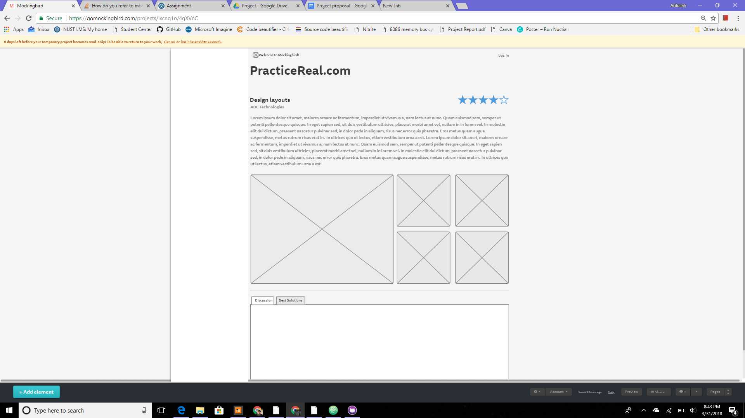

# Goals

1. **Provide students with real world problems:** Good practice problems are essential part of learning. Practice problems which are valid in real world are what we want to provide our customers(students)
2. **Sed diam nonummy nibh euismod:** Nam liber tempor cum soluta nobis eleifend option congue nihil imperdiet doming id quod mazim placerat facer possim assum.

# Specifications

The

# Milestones

## Lorem ipsum

Lorem ipsum dolor sit amet, consectetuer adipiscing elit, sed diam nonummy nibh euismod tincidunt ut laoreet dolore magna aliquam erat volutpat.

## Dolor sit amet

Lorem ipsum dolor sit amet, consectetuer adipiscing elit, sed diam nonummy nibh euismod tincidunt ut laoreet dolore magna aliquam erat volutpat.

## Consectetur adipiscing elit

Lorem ipsum dolor sit amet, consectetuer adipiscing elit, sed diam nonummy nibh euismod tincidunt ut laoreet dolore magna aliquam erat volutpat.